Linux Bash Scripting
Dan Richter
14 Sep 2020

If you were a dos/Windows user, and worked at all with the command line, you are probably aware of batch files. A single text file that could run a plethora of different commands, and programs. Well, Linux has that ability as well, but there’s even more possibilities.

First of all, what is BASH?

BASH is a command language interpreter. The name is an acronym for the “Bourne-Again Shell”.

Let’s say you always have to look up the name of the program that you run from the terminal. For this example, I’m going to run a program called MultiMail, which is an offline mail reader for BBSs. (That will be in a future article)

Now, when I installed the program, it installed it into a directory that contains the version number. As I’m not always awake enough to remember which version I have running, I always have to run ‘ls’ to get a listing of what’s in my home directory, change to that directory, look up the program name, and then run the program. Way too many steps for me. :)

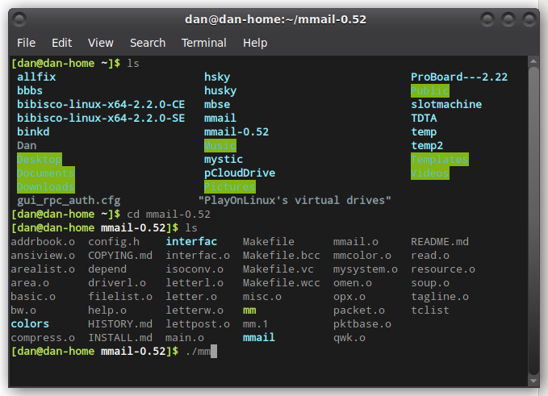
So, what we’re going to do, is make this all happen in one easy script. First open a text editor, either command line or gui, and create a new file. I’ll use Pluma, as I think it will be easier for you to see what I’m doing.


The first line of the script needs to be what is called a SheBang. This tells the terminal what program to call to run this script. You might see some that will have ‘#!/bin/ksh’, or ‘#!/bin/shell’. I prefer to work with bash, as that’s what I’m more familiar with.

Now, we need the script to change to the directory ‘mmail-0.52’. So, we’ll add that on the next line.
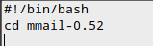
Ok, so now we’re in the right directory, let’s run the program.
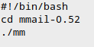
And that’s it. Now, we’ll name the file ‘/home/dan/mm.sh’. In Linux, you are not required to have an extension at the end of the filename. I like to add the ‘.sh’ to indicate that it’s a script file. It’s more for my sanity than anything else.

So, we can now go to our terminal, and run the script, right?
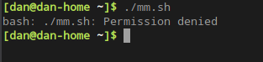
Nope, not quite. We forgot a step. Remember, we have to tell Linux that this file is executable. We could do that through the file manager, or via the command line. Since we’re already at the command line, let’s do it there.
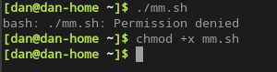
Remember that command? Now we should be able to run the program.

From our home directory, in this case ‘/home/dan’, all I have to type in is ‘./mm.sh’ and the script will change to the correct directory, and run the program for me.

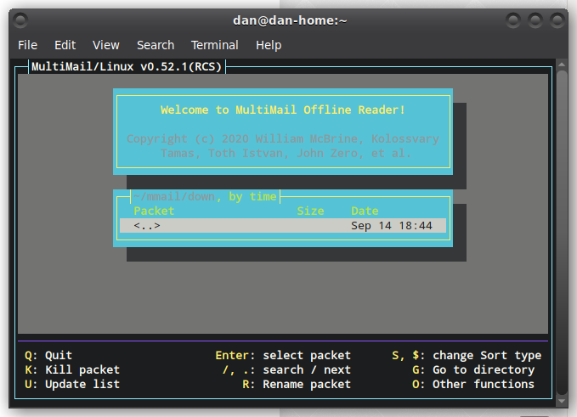
There we are, the program now runs.

This is just the very basics of what can be done with a bash script. Bash has the capability of using variables, functions, etc. It is, in some ways, more powerful than a programming language.

